Pop-Up Shop Analysis

Where to do a pop-up shop for women’s activity clothing store?

# Purpose

Having a store front can add a lot of overhead and extra cost to running a business, particularly smaller businesses that have a very targeted clientele. It has become more common to see random pop-up stores at temporary locations. The operator of these shops have low overhead for facilities and have the flexibility to setup close to their clients. Store fronts for high end women’s athletic clothing (i.e. Lululemon and Athleta) are very scarce so it would be ideal to do a pop-up shop for these types of stores. The purpose of this analysis is to help identify ideal locations to help support a pop-up store, and a good place would be at a coffee shop (preferable locally owned) close to a yoga studio.

# Audience

While this analysis was targeted for someone who wants to set-up a women’s athletic clothing pop-up shop near a Yoga studio, it could also benefit anyone that wants to correlate a Yoga studio with a coffee shop. This could also be used by someone who wanted to sell herbal supplements as a beverage to the coffee shop to help target healthy life styled individuals.

# Data

* We first target venues in Iowa City so the first pieces of data the latitude and longitude coordinates for Iowa City
  + Latitude – 41.6611
  + Longitude – -91.5302
  + This was obtained from performing a Google Search.
* The second piece of data is a list of all the Coffee Shops within a 10 KM radius of Iowa City.
  + This was obtained from using the Foursquare API using the venues search.
  + ShopsCategoryId = '4bf58dd8d48988d1e0931735‘
  + Key data elements used are Name, Latitude and Longitude.
  + 30 Coffee Shops were returned.
  + 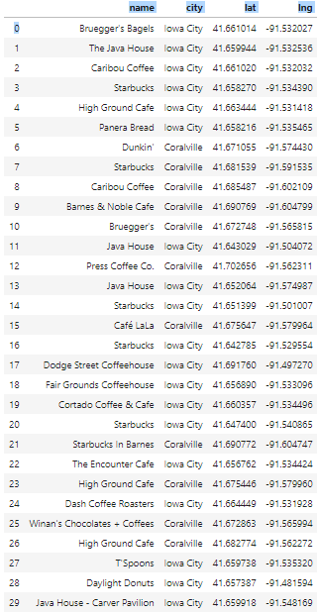
* The last piece of data is a list of all the Yoga Studios within a 10 KM radius of Iowa City.
  + This was obtained from using the Foursquare API using the venues search.
  + CategoryId = '4bf58dd8d48988d102941735‘
  + Key data elements used are Name, Latitude and Longitude.
  + 8 Yoga Studios were returned.
  + 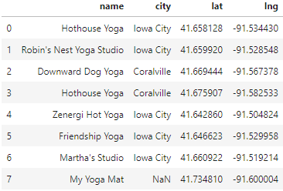

# Analysis

To perform the analysis, all of the Yoga Studios and Coffee Shops were mapped using Folium.

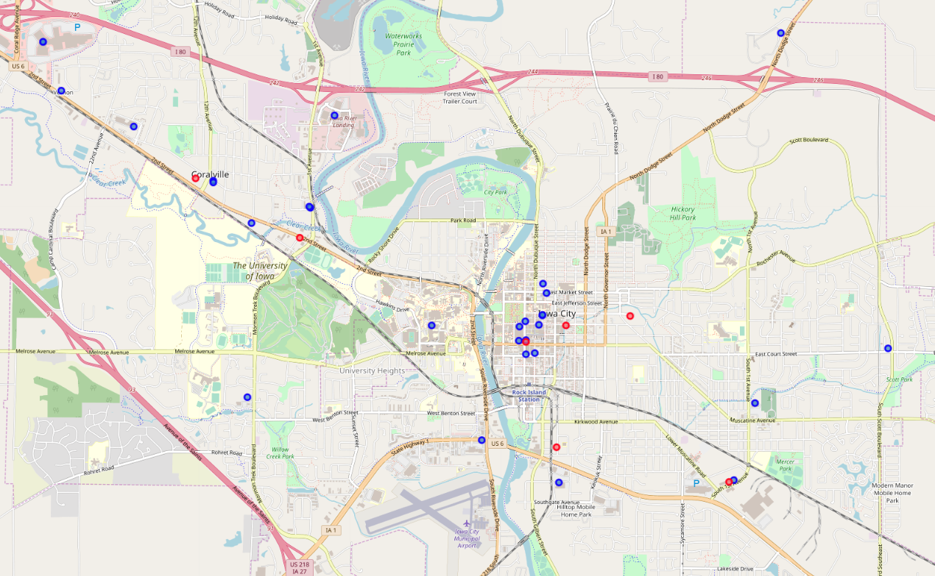

Based on the mapping, there are two Yoga Studios (red) that are very close to Coffee Shops (blue). There is another that is somewhat close as well in Coralville, which is a neighbor town of Iowa City. There are 4 Yoga Studios that are a bit further from coffee shops. The last coffee shop (My Yoga Mat) is not in the Iowa City view based on the zoom of the map so it was not included.

Based on the relative location of Yoga Studios to Coffee Shops, I’ve identified 3 Yoga Studios to target.

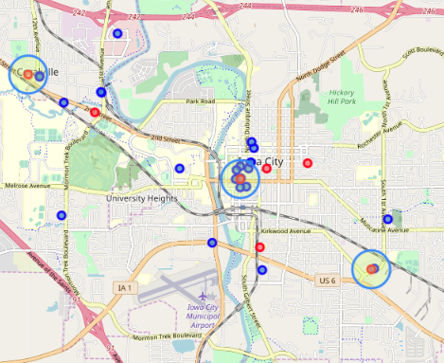

# Conclusion

Based on proximity of Yoga Studios and Coffee Shops, both Hothouse Yoga and Zenergi Hot Yoga studios would be ideal studios to target for a pop-up shop. Coffee shops, particularly local/non-chain coffee shops, tend to be more supportive of local businesses and may be willing to hose a pop-up shop due to the business that it would attract. I would recommend asking the following Coffee Shops about setting up a pop-up shop, and let the Yoga Studios know the time and place of the event.

* + High Ground Cafe near Hothouse Yoga in Coralville
  + Java House near Zenergi Hot Yoga in Iowa City
  + Fair Grounds Coffeehouse or The Encounter Cafe near Hothouse Yoga in Iowa City